Usiel Figueroa

June 25, 2025

CSD 430-A311 Server-Side Development

Module 7 Assignment: Project Part 2

* **Mission: Add records to a database using JavaBeans.**

A form that gathers data from the user for adding a record to the data held in the db. The form will hold all HTML entry fields for gathering the user input data. The key value will be added when the data form has been submitted. The returning data display will be all records in a table format having all fields in a separate table column along with field titles in the thread section of the table.

**Screenshots**

Error (Try & Catch)

Program Files Screenshots

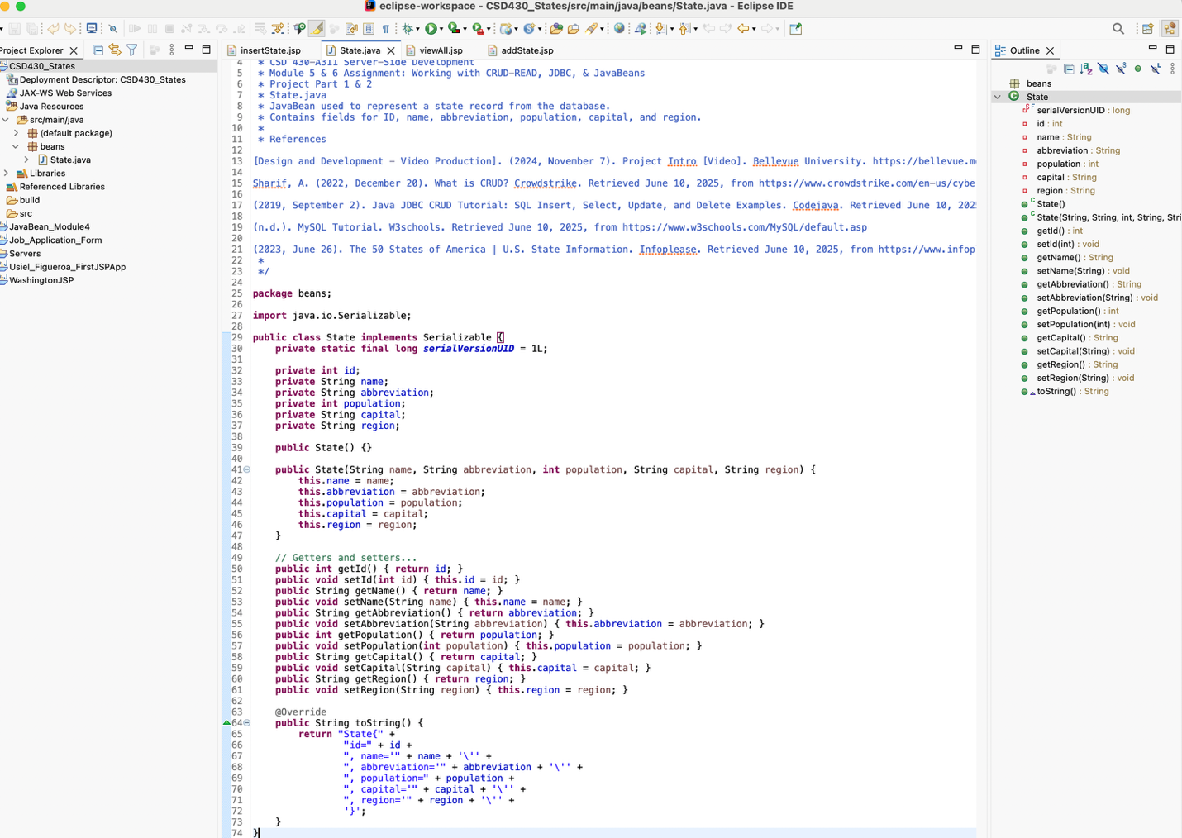

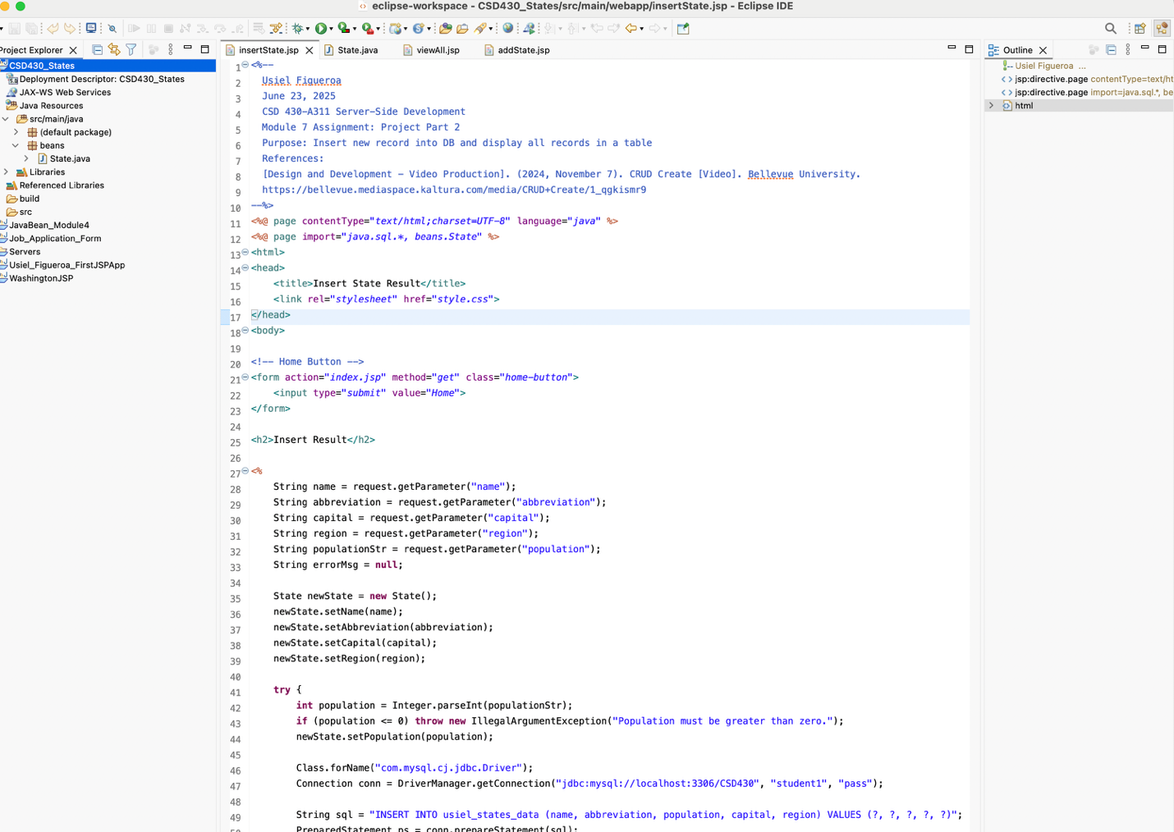

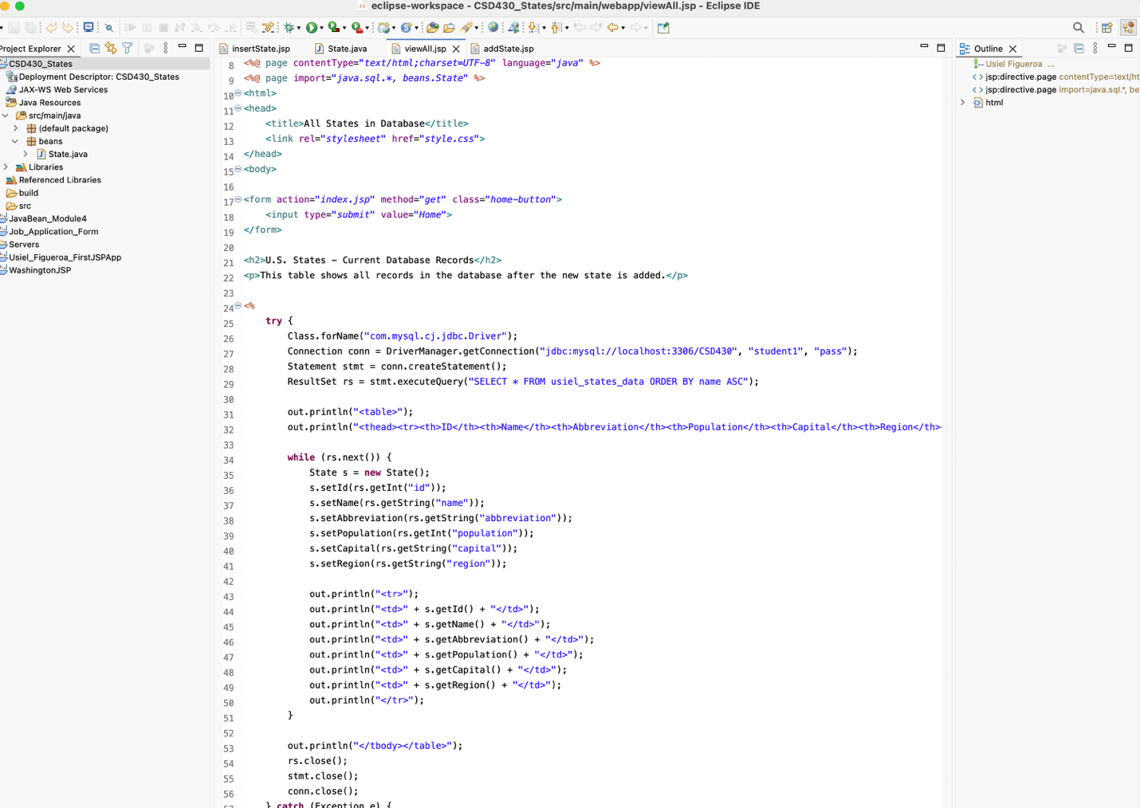

**References**

[Design and Development - Video Production]. (2024, November 7). *CRUD Create* [Video]. Bellevue University. https://bellevue.mediaspace.kaltura.com/media/CRUD+Create/1_qgkismr9